SWD607 – Mobile Application

Valcorton | NZSE

Recipal

Group 3 – marvin Coronel, darren burton & rocelle valdez

2023

Contents

Part A – Implementation 5

Task 1: Mobile Application Screens Development 5

Task 2: RESTful Web Service 56

Part B – Database Integration 60

Task 1: 60

Part C – Test and Debug 64

Task 1: Testing 64

Part D – Reflection 66

Task 1: Self-Reflection 66

Task 1: Self-Reflection 68

Task 1: Self-Reflection 69



**School of Information Technology**

**New Zealand Diploma in Software Development (Level 6)**

**Cover Sheet and Student Declaration**

This sheet must be signed by the student and attached to the submitted assessment.

|  |  |  |  |
| --- | --- | --- | --- |
| **Course Title:** | Mobile and App Development | **Course code:** | **SWD607** |
| **Student Name:** | **Darren Burton** | **Student ID:** | **764702111** |
| **Assessment No & Type:** | Assessment 2 Project Portfolio | **Cohort:** | **NZDSD6221C** |
| **Due Date:** | 30/04/2023 | **Date**  **Submitted:** | 30/04/2023 |
| **Tutor’s Name:** | **Jatinder Singh** |  |  |
| **Assessment**  **Weighting** | 60% |  |  |
| **Total Marks** | 100 |  |  |

**Student Declaration:**

I declare that:

* I have read the New Zealand School of Education Ltd policies and regulations on assessments and understand what plagiarism is.
* I am aware of the penalties for cheating and plagiarism as laid down by the New Zealand School of Education Ltd.
* This is an original assessment and is entirely my own work.
* Where I have quoted or made use of the ideas of other writers, I have acknowledged the source.
* This assessment has been prepared exclusively for this course and has not been or will not be submitted as assessed work in any other course.
* It has been explained to me that this assessment may be used by NZSE Ltd, for internal and/or external moderation.
* If I am late in handing in this assessment without prior approval (see student regulations in handbook), marks will be deducted, to a maximum of 50%.

**Student signature: **

**Date:** 30/04/2023

|  |  |  |
| --- | --- | --- |
| **Tutor only to complete** |  |  |
| **Assessment result:** | **Mark /100** | **Grade** |



**School of Information Technology**

**New Zealand Diploma in Software Development (Level 6)**

**Cover Sheet and Student Declaration**

This sheet must be signed by the student and attached to the submitted assessment.

|  |  |  |  |
| --- | --- | --- | --- |
| **Course Title:** | Mobile and App Development | **Course code:** | **SWD607** |
| **Student Name:** | **Marvin Coronel** | **Student ID:** | **764700878** |
| **Assessment No & Type:** | Assessment 2 Project Portfolio | **Cohort:** | **NZDSD6221C** |
| **Due Date:** | 30/04/2023 | **Date**  **Submitted:** | 30/04/2023 |
| **Tutor’s Name:** | **Jatinder Singh** |  |  |
| **Assessment**  **Weighting** | 60% |  |  |
| **Total Marks** | 100 |  |  |

**Student Declaration:**

I declare that:

* I have read the New Zealand School of Education Ltd policies and regulations on assessments and understand what plagiarism is.
* I am aware of the penalties for cheating and plagiarism as laid down by the New Zealand School of Education Ltd.
* This is an original assessment and is entirely my own work.
* Where I have quoted or made use of the ideas of other writers, I have acknowledged the source.
* This assessment has been prepared exclusively for this course and has not been or will not be submitted as assessed work in any other course.
* It has been explained to me that this assessment may be used by NZSE Ltd, for internal and/or external moderation.
* If I am late in handing in this assessment without prior approval (see student regulations in handbook), marks will be deducted, to a maximum of 50%.

**Student signature:**

**Date:** 30/04/2023

|  |  |  |
| --- | --- | --- |
| **Tutor only to complete** |  |  |
| **Assessment result:** | **Mark /100** | **Grade** |



**School of Information Technology**

**New Zealand Diploma in Software Development (Level 6)**

**Cover Sheet and Student Declaration**

This sheet must be signed by the student and attached to the submitted assessment.

|  |  |  |  |
| --- | --- | --- | --- |
| **Course Title:** | Mobile and App Development | **Course code:** | **SWD607** |
| **Student Name:** | **Rocelle Valdez** | **Student ID:** | **1816450** |
| **Assessment No & Type:** | Assessment 2 Project Portfolio | **Cohort:** | **NZDSD6221C** |
| **Due Date:** | 30/04/2023 | **Date**  **Submitted:** | 30/04/2023 |
| **Tutor’s Name:** | **Jatinder Singh** |  |  |
| **Assessment**  **Weighting** | 60% |  |  |
| **Total Marks** | 100 |  |  |

**Student Declaration:**

I declare that:

* I have read the New Zealand School of Education Ltd policies and regulations on assessments and understand what plagiarism is.
* I am aware of the penalties for cheating and plagiarism as laid down by the New Zealand School of Education Ltd.
* This is an original assessment and is entirely my own work.
* Where I have quoted or made use of the ideas of other writers, I have acknowledged the source.
* This assessment has been prepared exclusively for this course and has not been or will not be submitted as assessed work in any other course.
* It has been explained to me that this assessment may be used by NZSE Ltd, for internal and/or external moderation.
* If I am late in handing in this assessment without prior approval (see student regulations in handbook), marks will be deducted, to a maximum of 50%.

**Student signature:**

**Date:** 30/04/2023



|  |  |  |
| --- | --- | --- |
| **Tutor only to complete** |  |  |
| **Assessment result:** | **Mark /100** | **Grade** |

# Part A – Implementation

## Task 1: Mobile Application Screens Development

Implemented all 10 screens of the Mobile Application:

 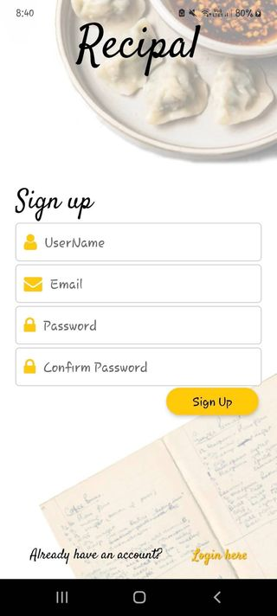

*Splash Screen Sign Up Screen*

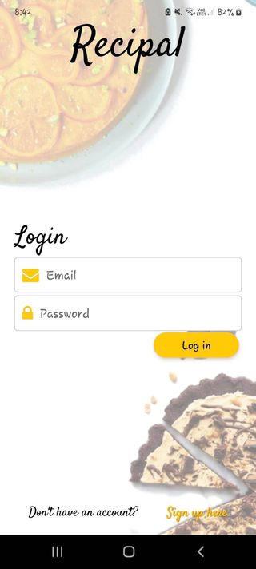 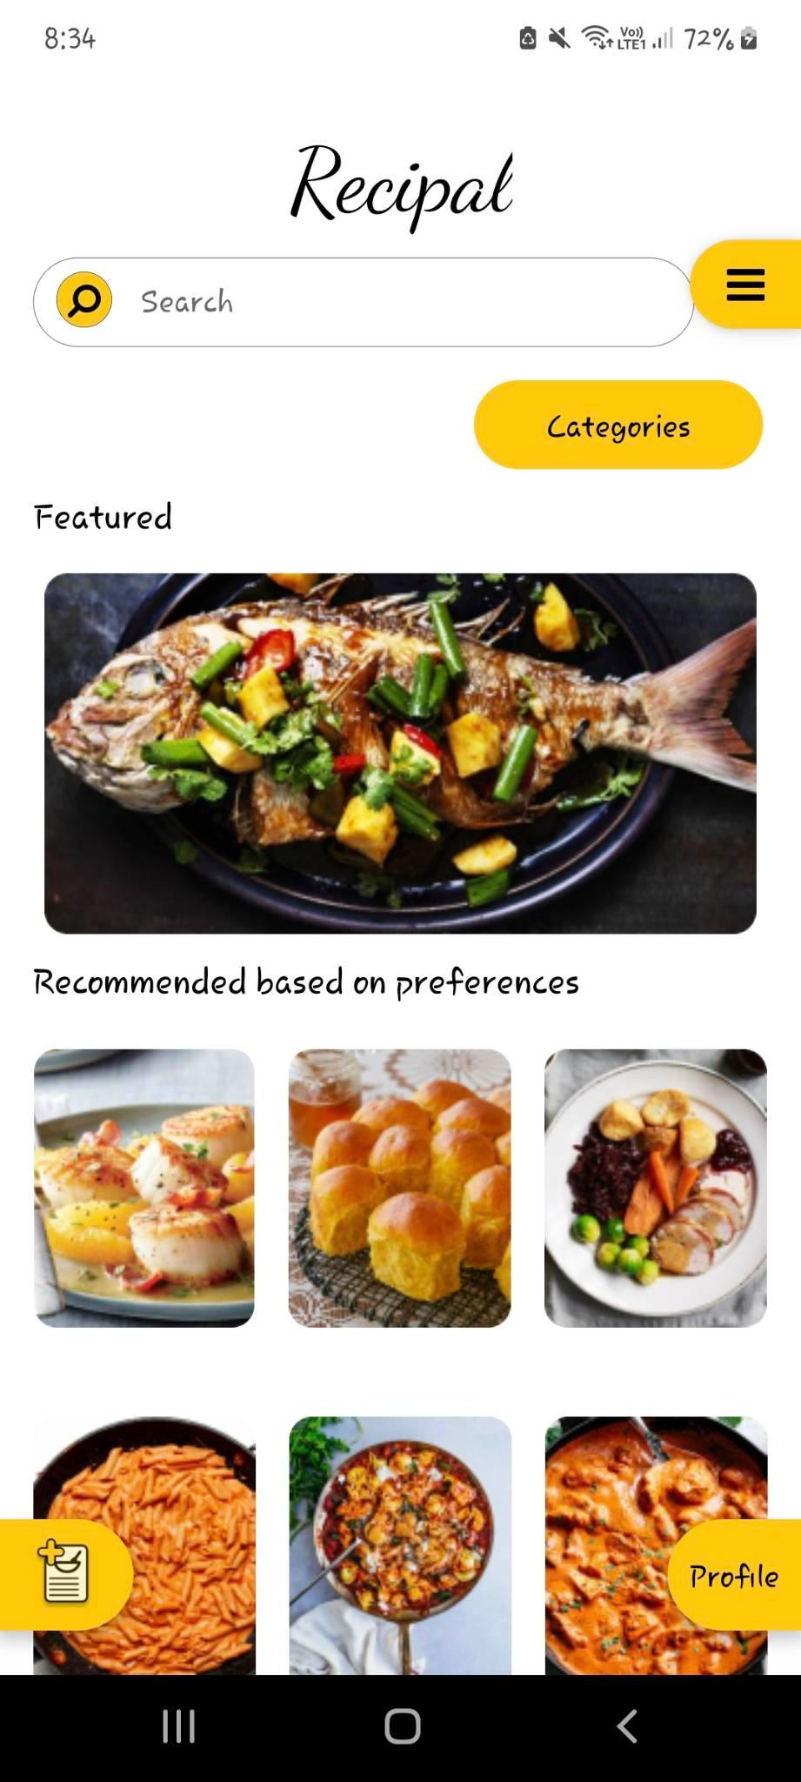

*Login Screen Home Page/Screen*

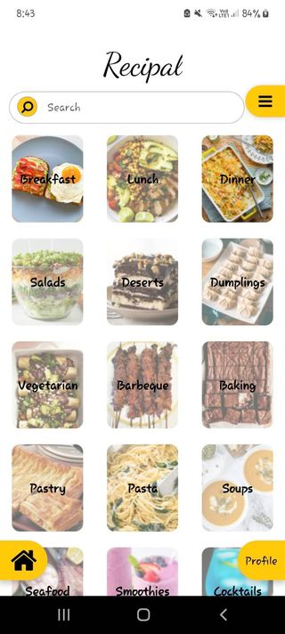 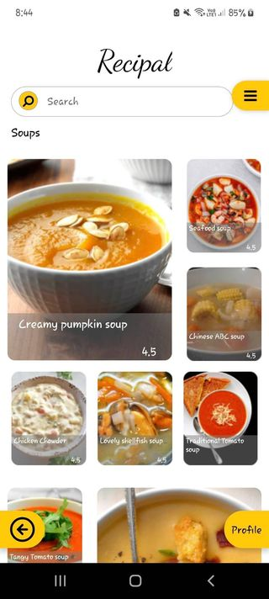

*Categories Page/Screen Saarch Page/Screen*

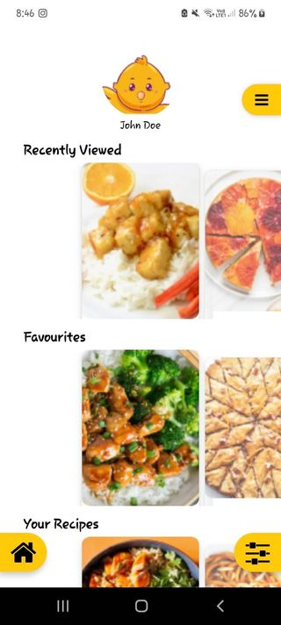 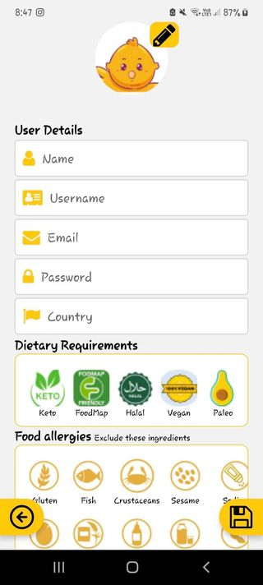

*User Profile Page/Screen Profile Edit Page/Screen*

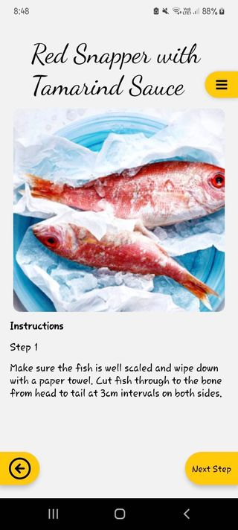 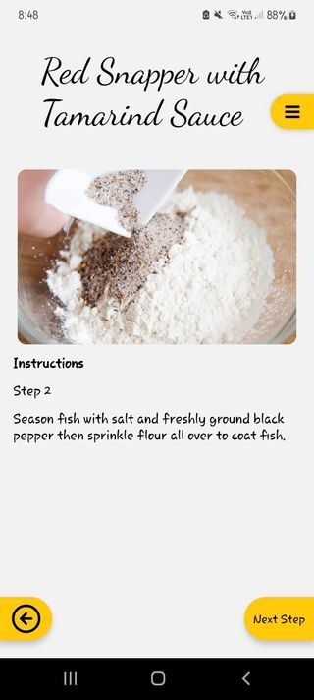

*Step-By-Step Page/Screen*

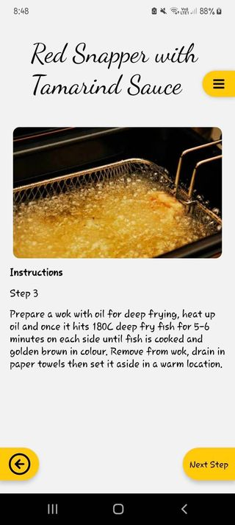 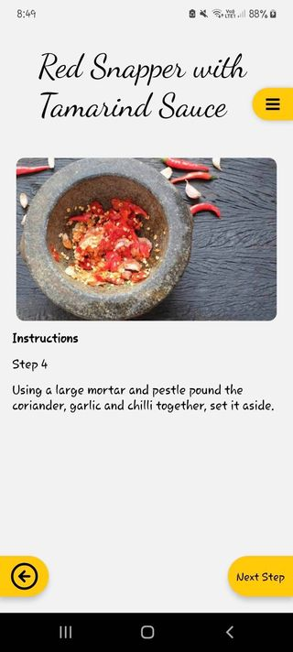

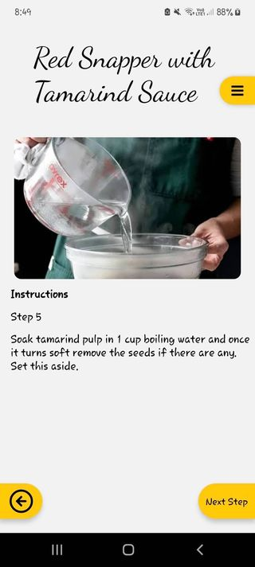 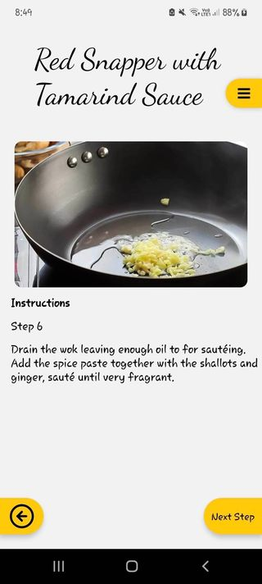

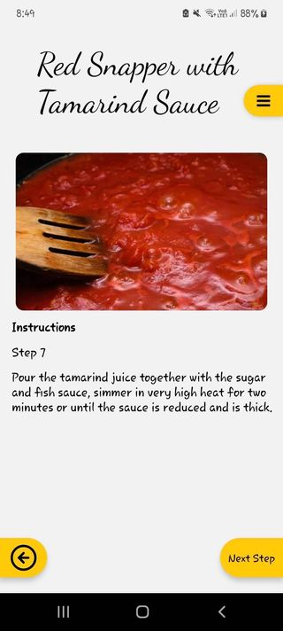 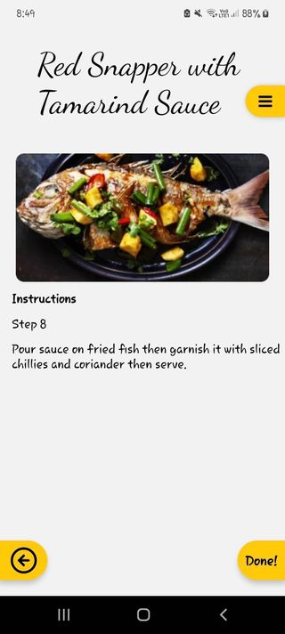

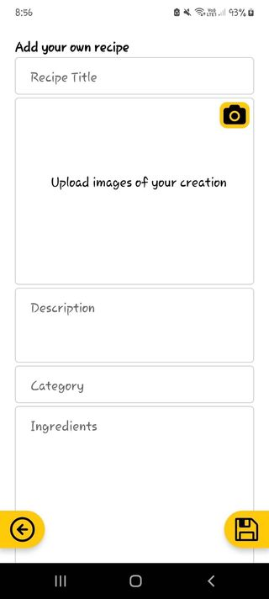 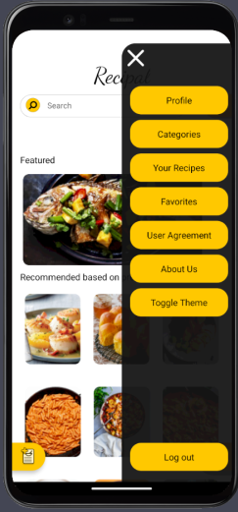

*User Recipe Page/Screen Side Menu Screen*

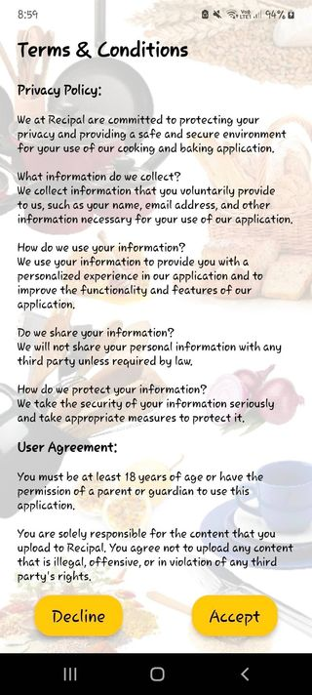 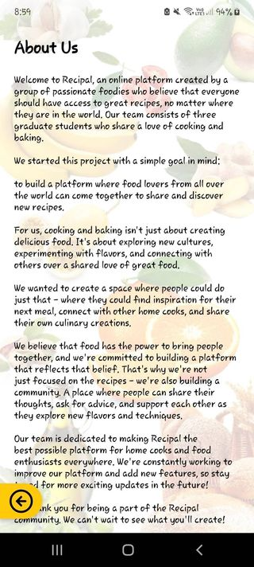

*Privacy Policy Page/Screen About Us Page/Screen*

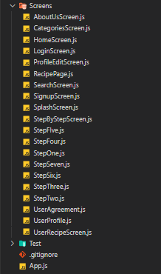

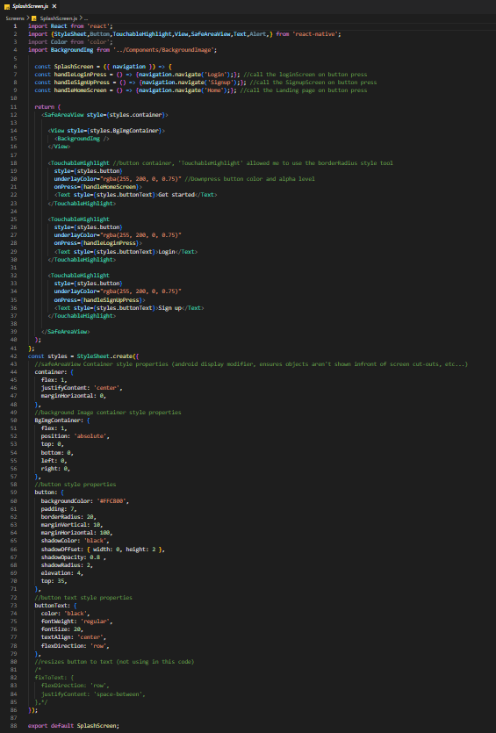

Splash Screen

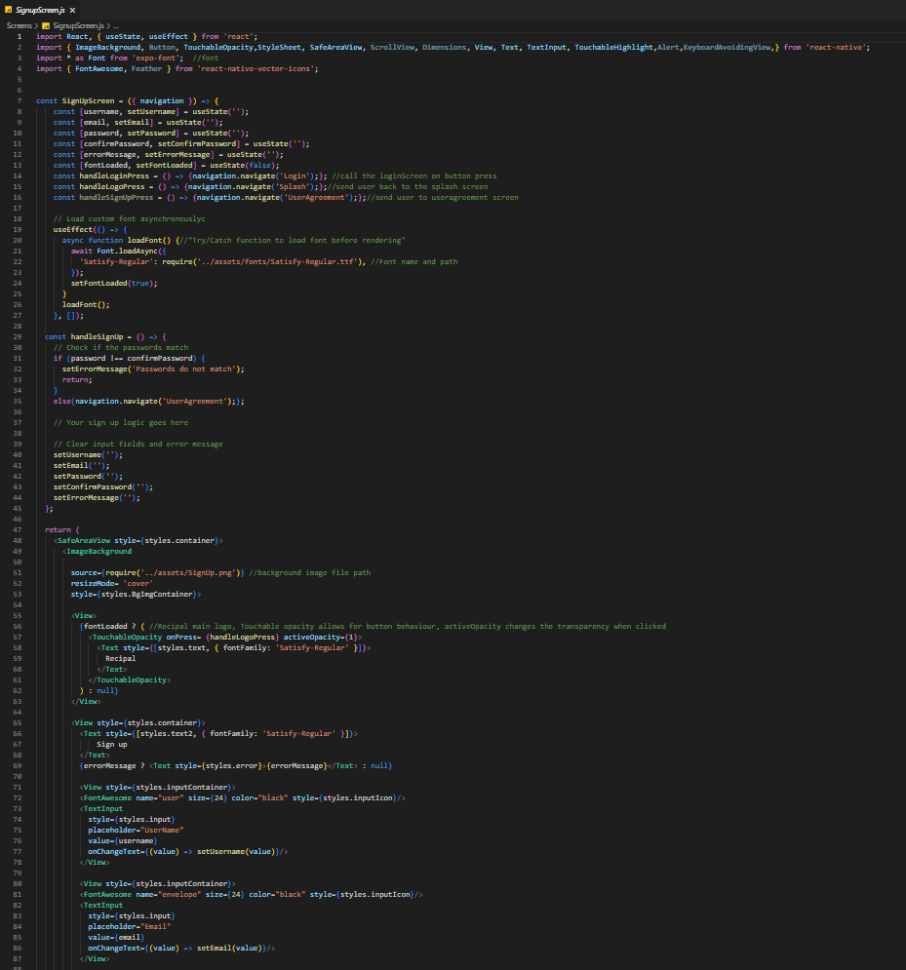

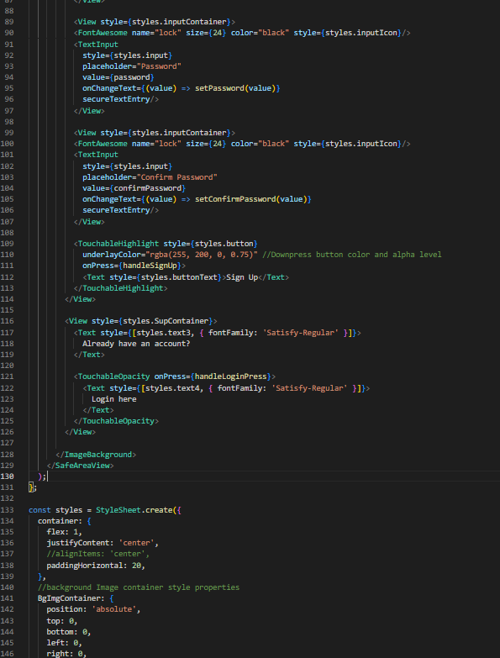

Sign Up Screen

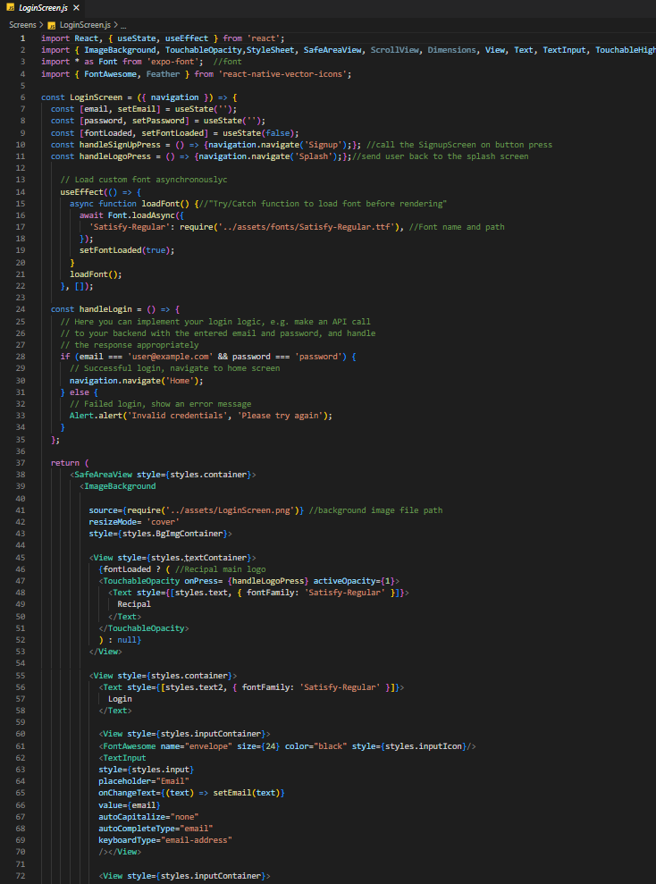

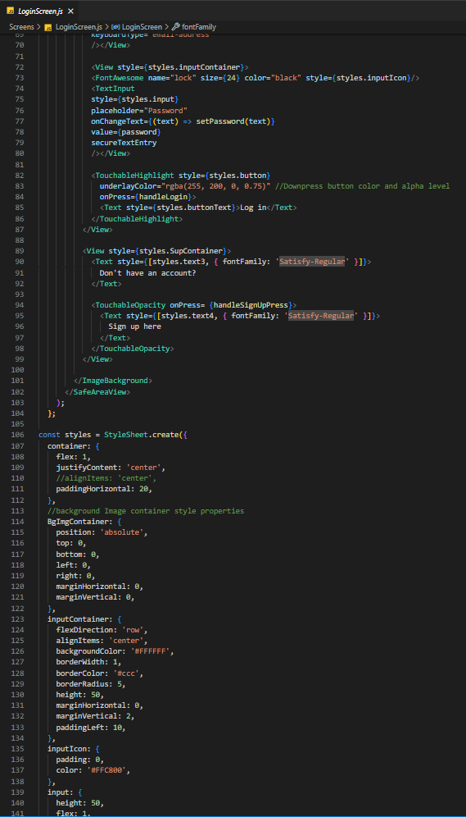

Login Screen

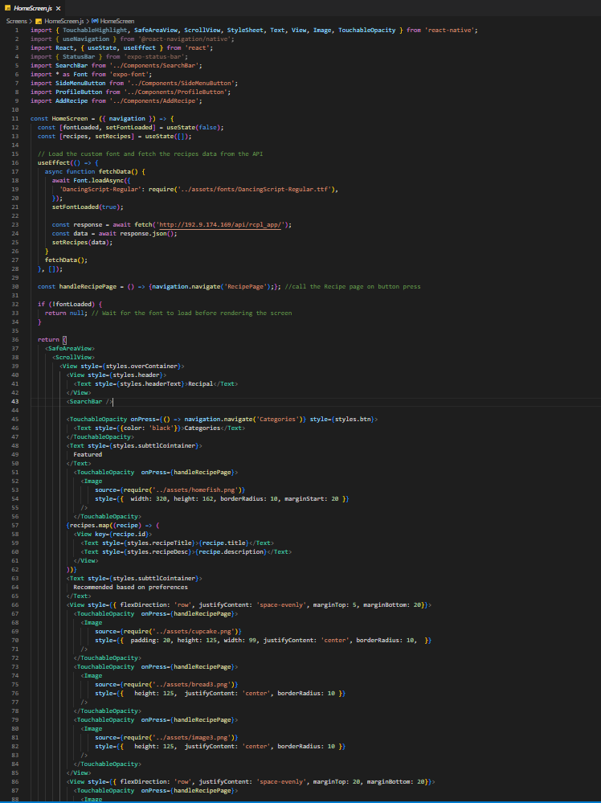

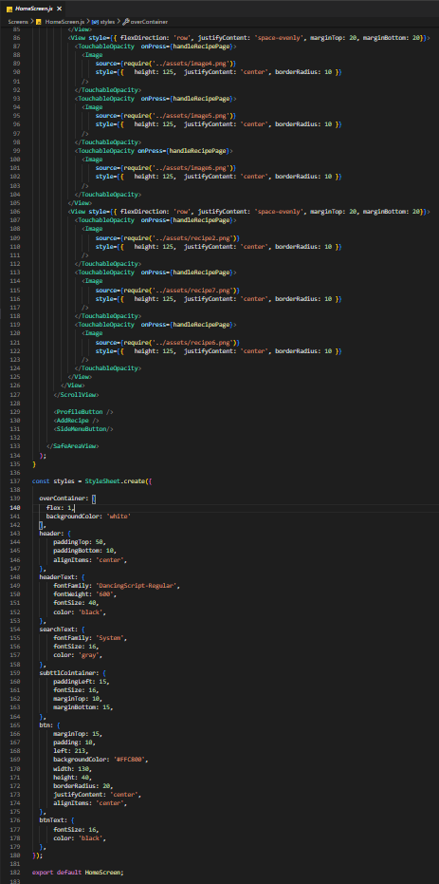

Home Screen

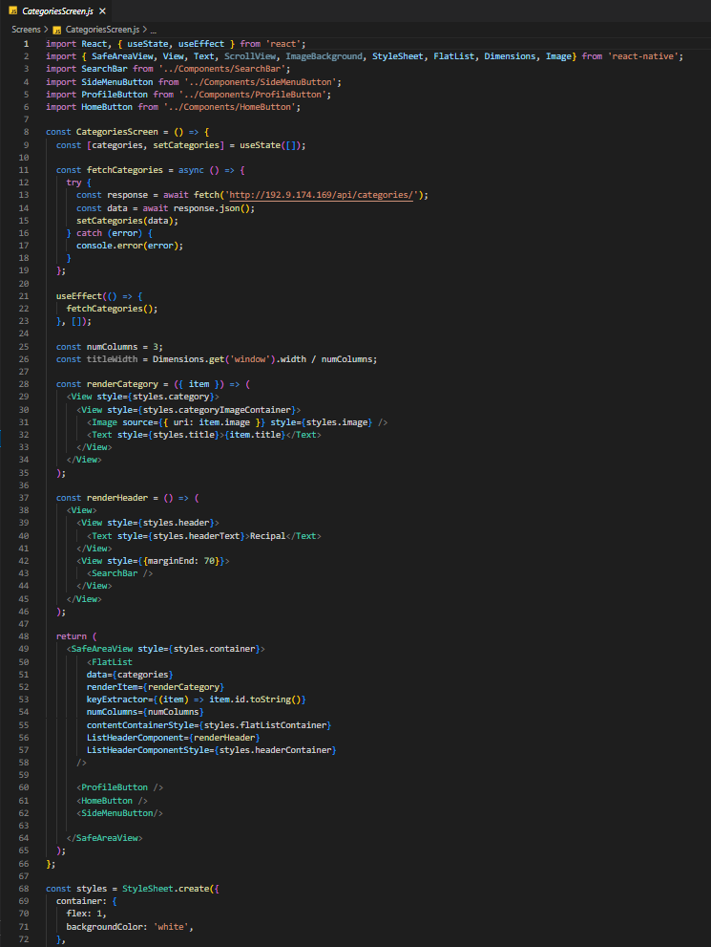

Categories Screen

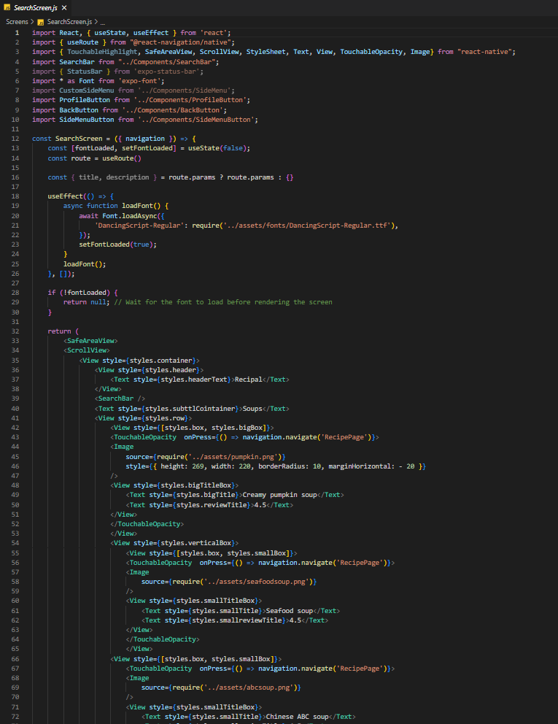

Search Screen

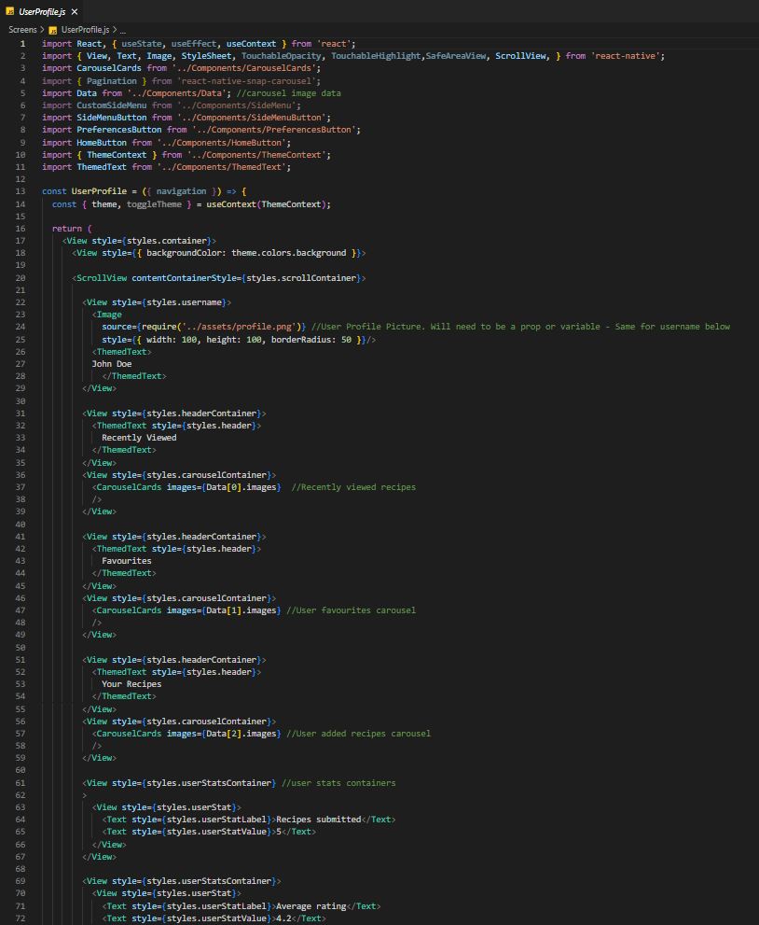

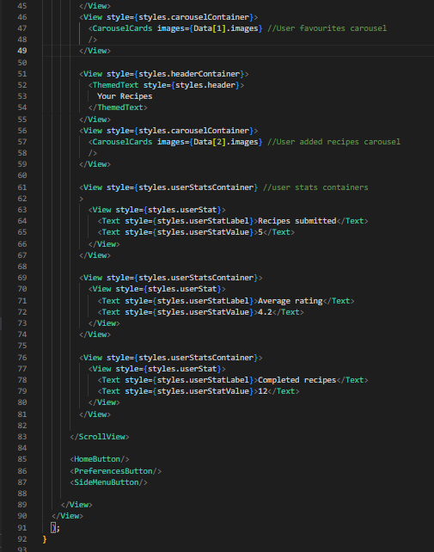

User Profile Screen

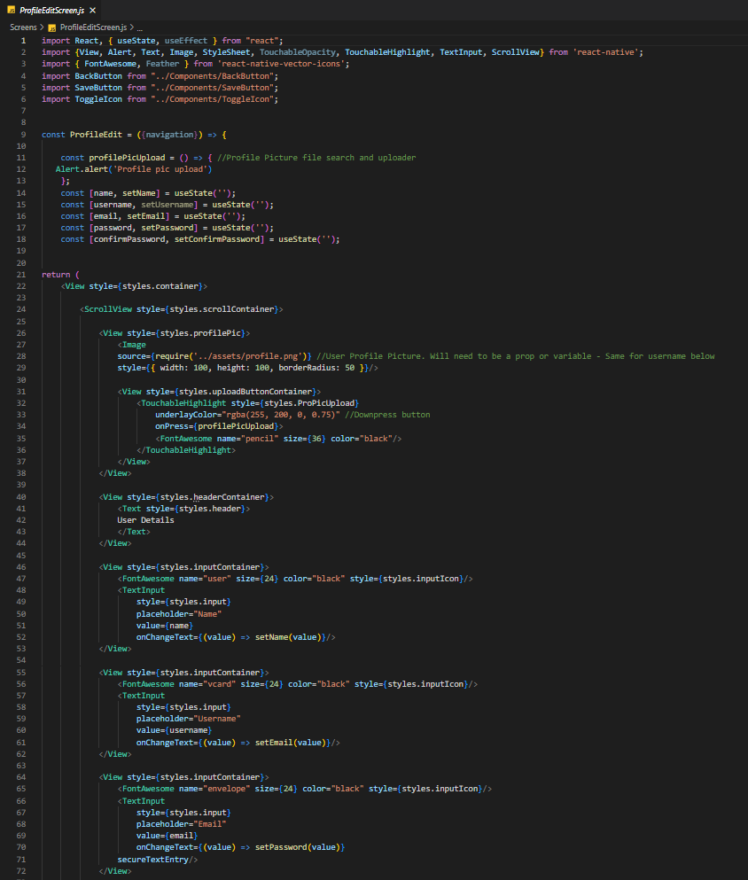

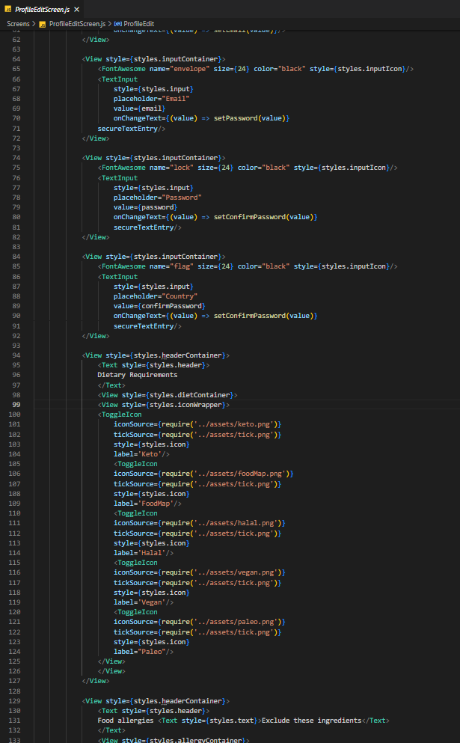

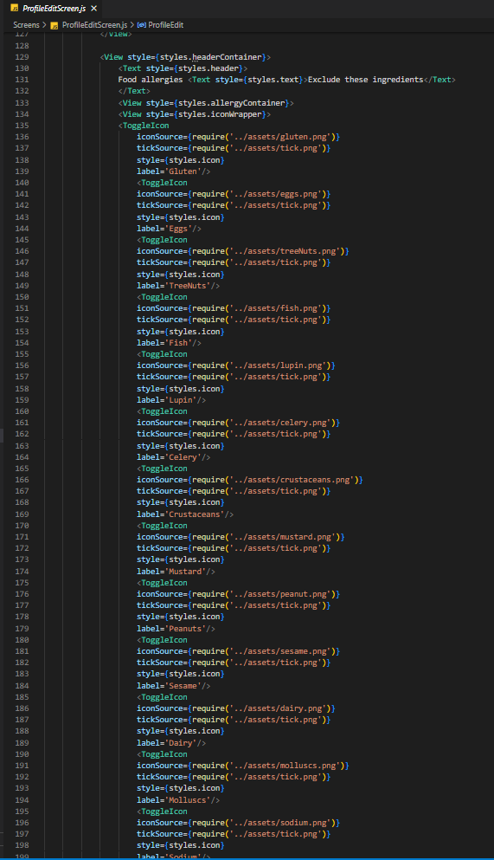

Profile Edit Screen

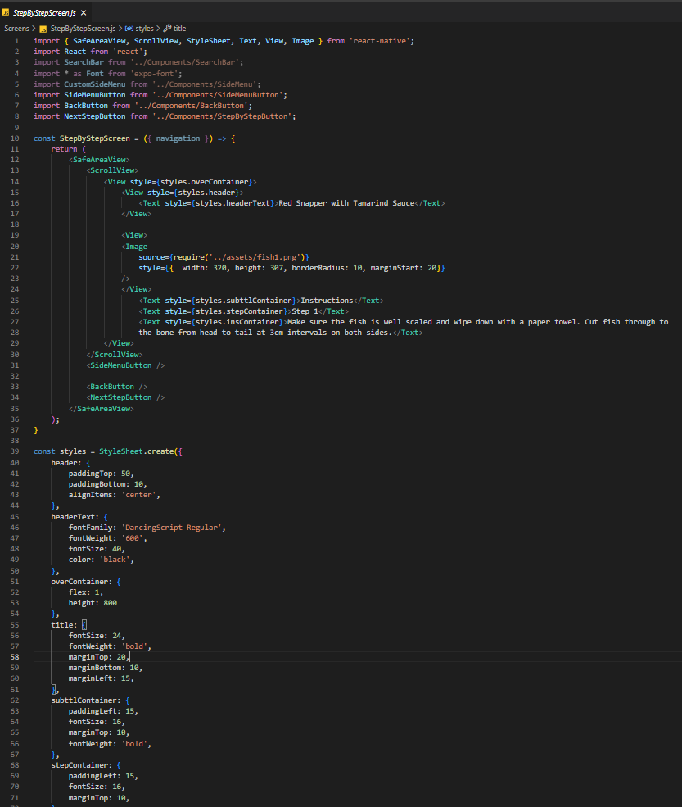

Step By Step Screen

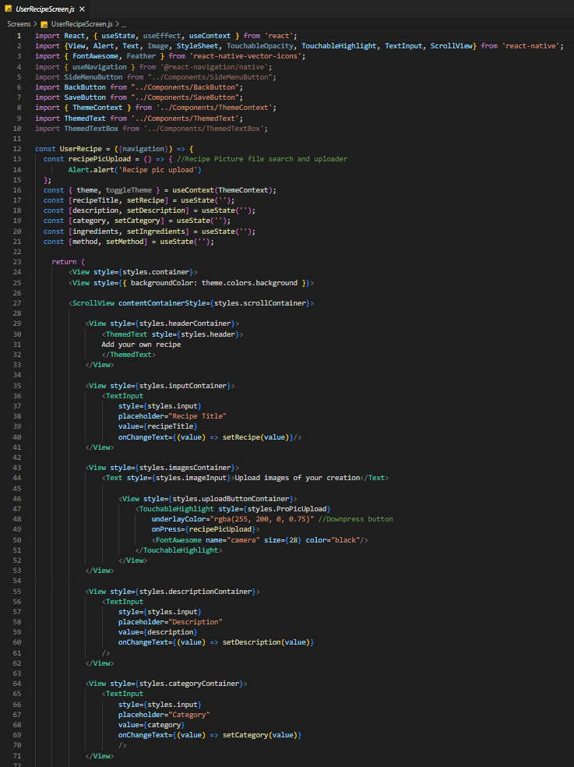

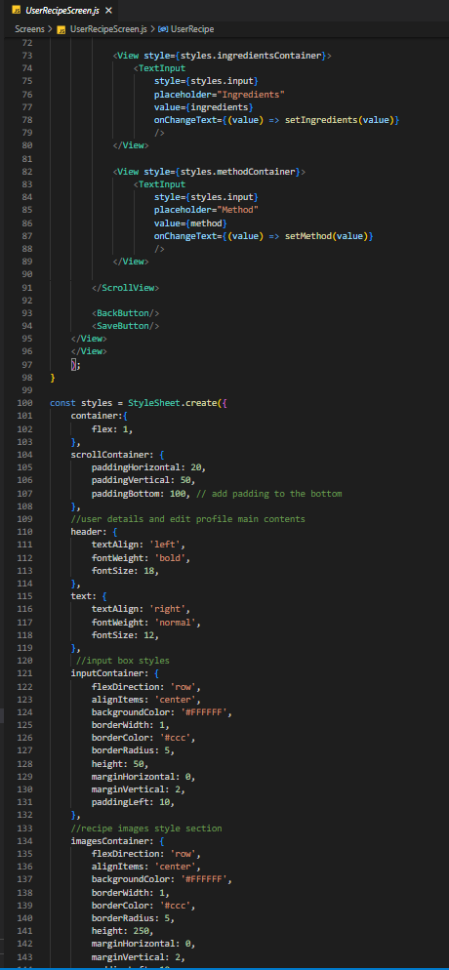

User Recipe Screen

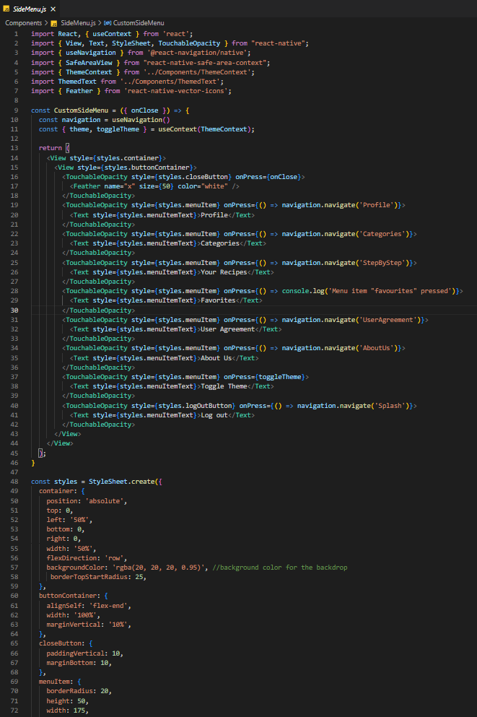

Side Menu Screen

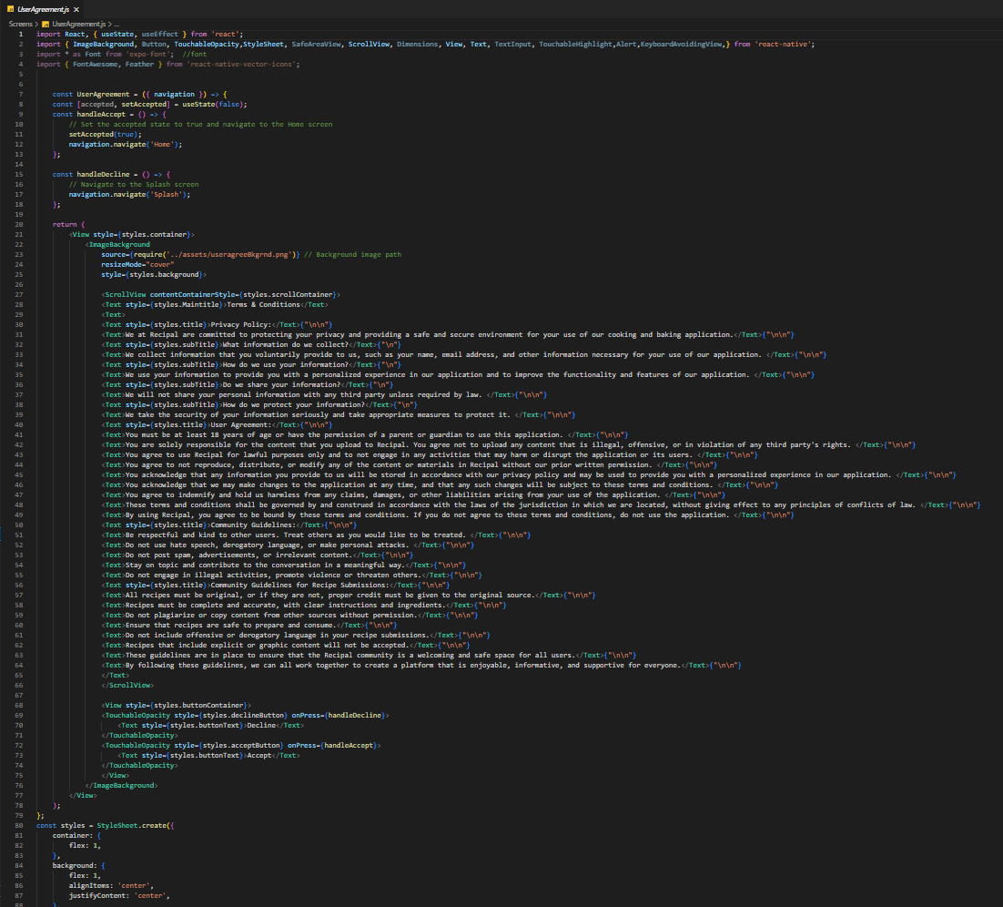

Privacy Policy Screen

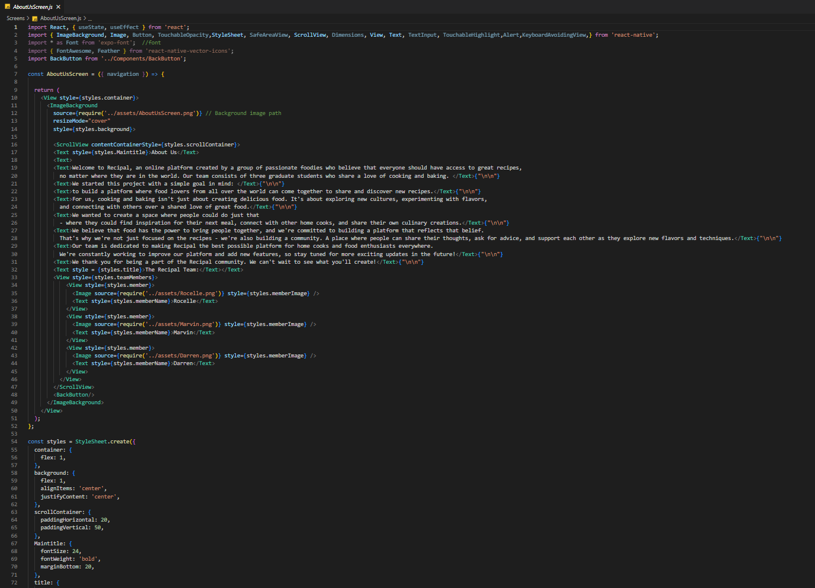

About Us Screen

* UI Controls:

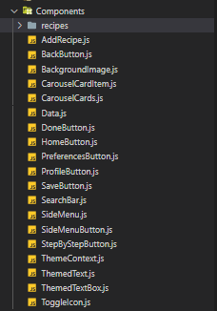

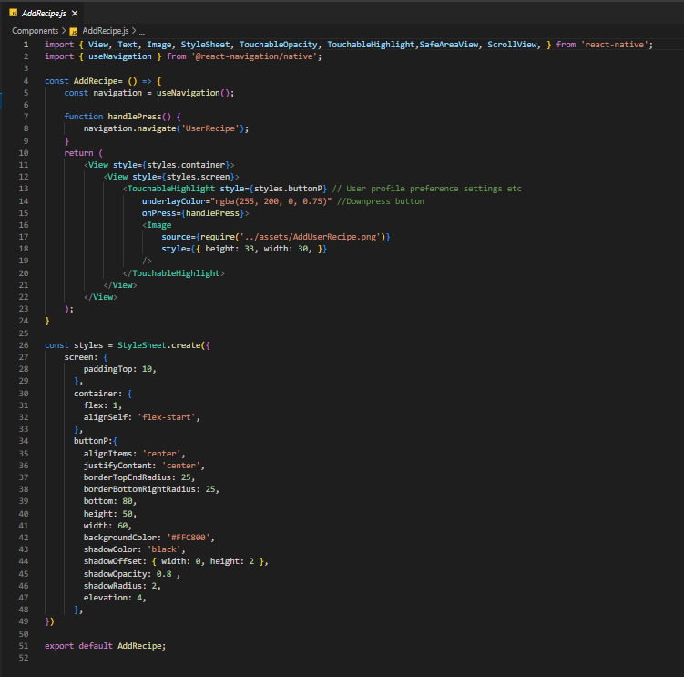

Add Recipe Button

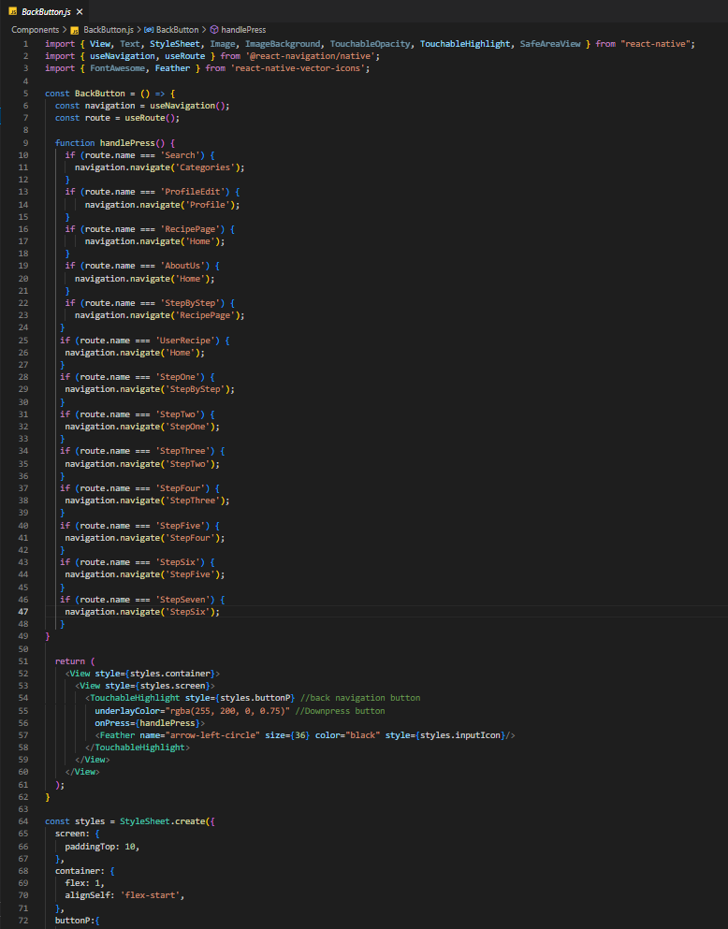

Back Button

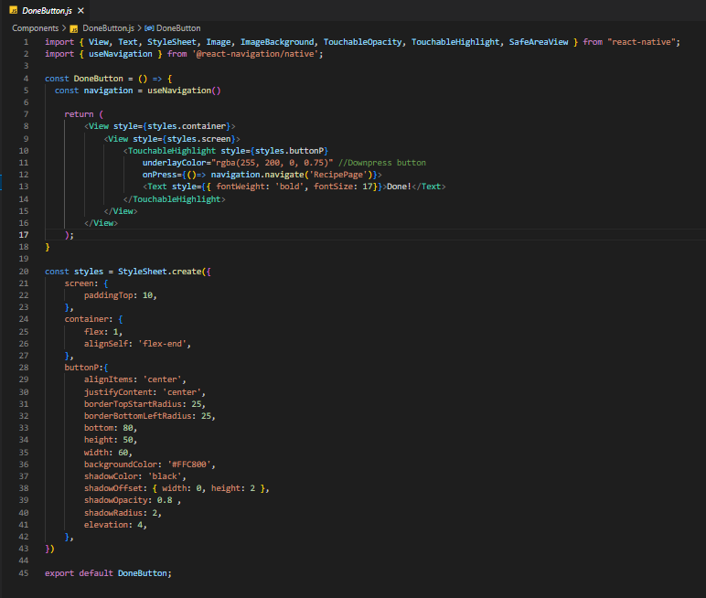

Done Button

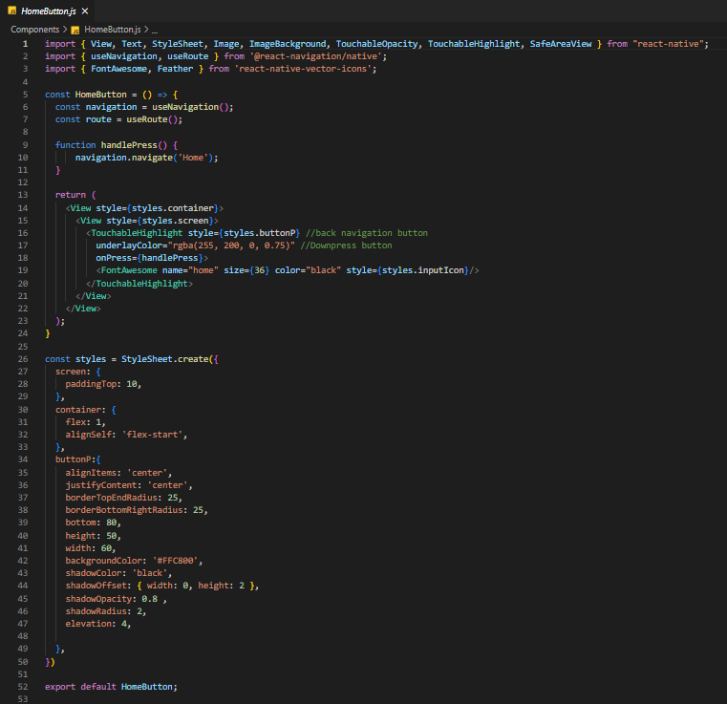

Home Button

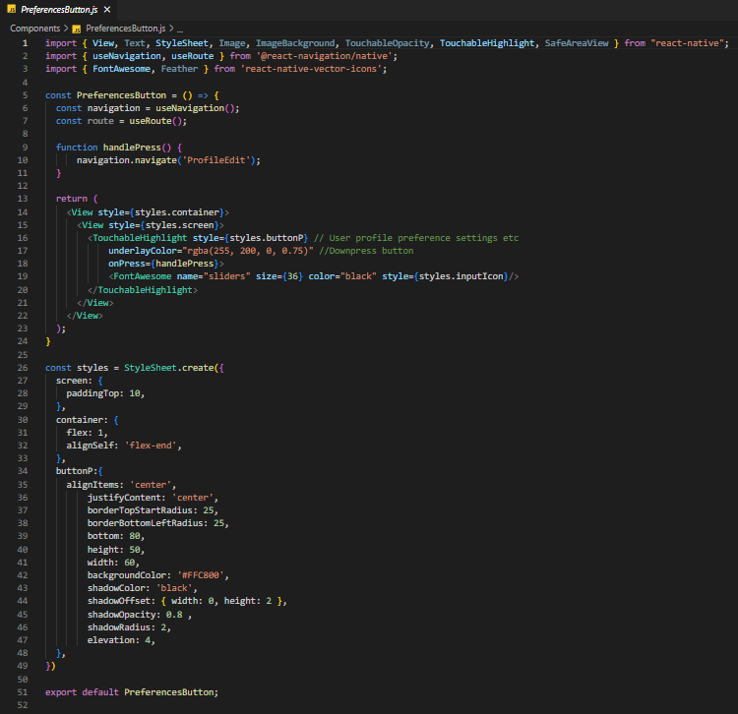

Preference Button

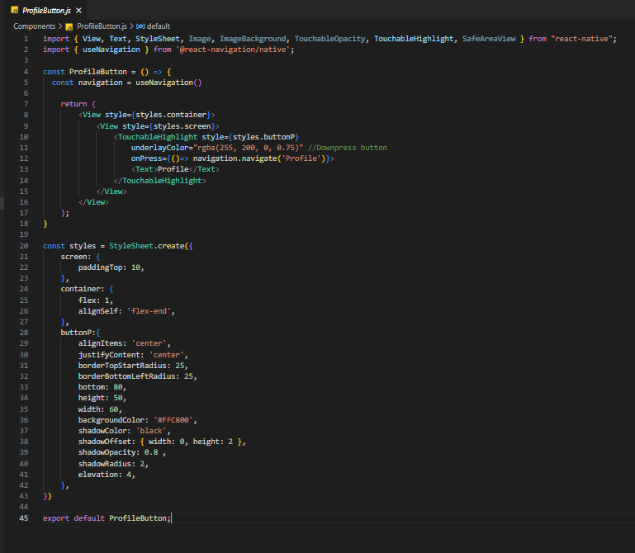

Profile Button

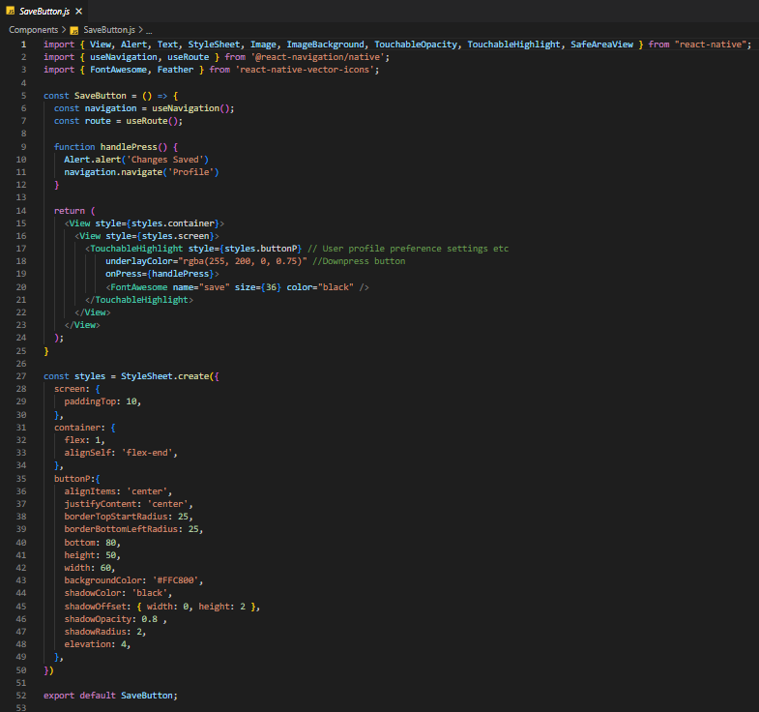

Save Button

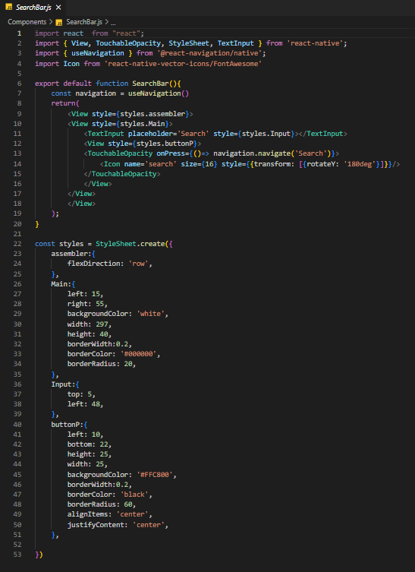

Search Bar

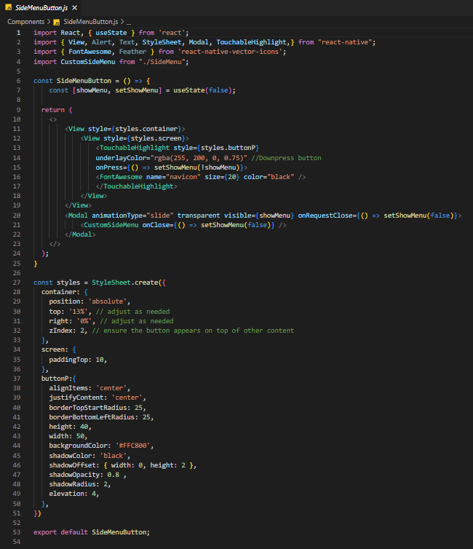Side Menu Button

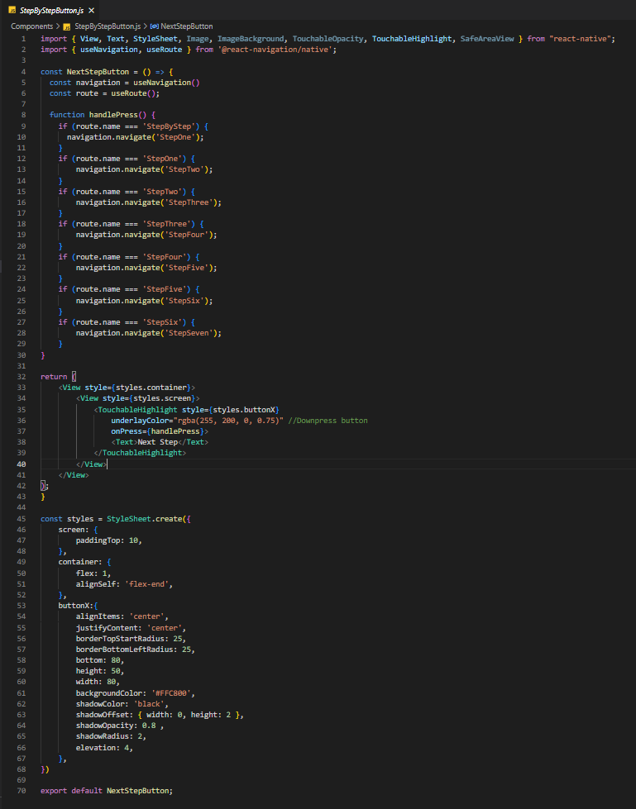

Step By Step Button

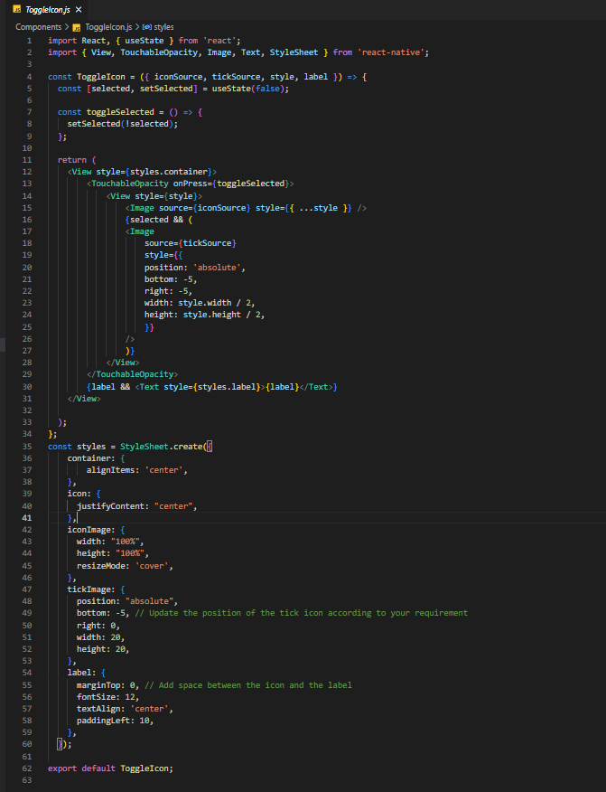

Toggle Icon

* UI Layout:

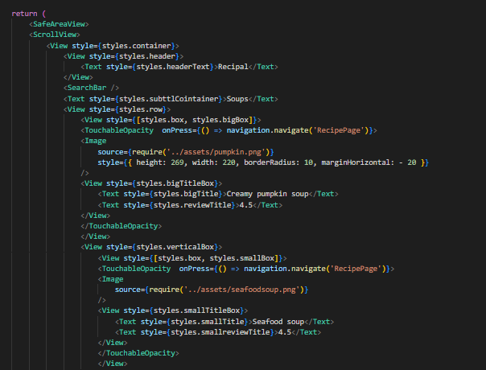

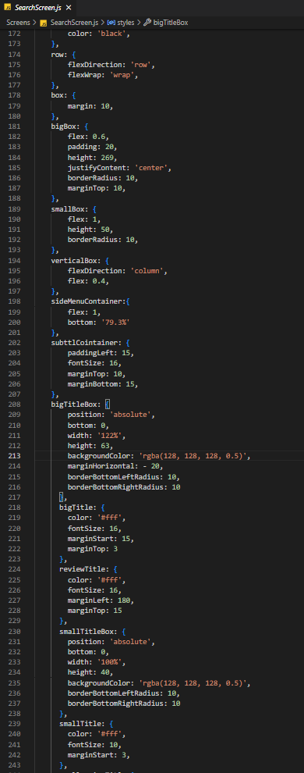

Search Screen Image/Item content lay out.

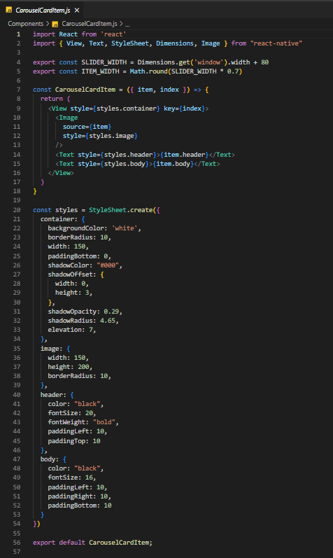

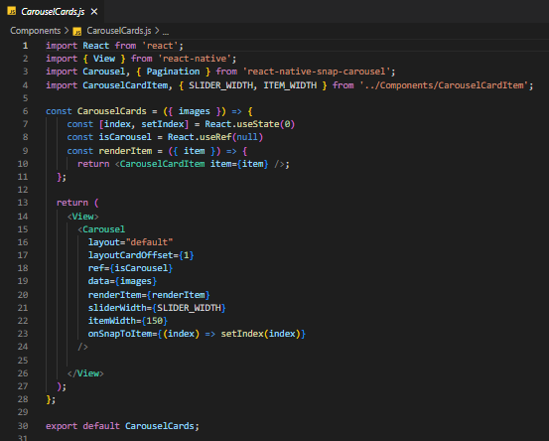

Carrousel Cards Image/Item content lay out.

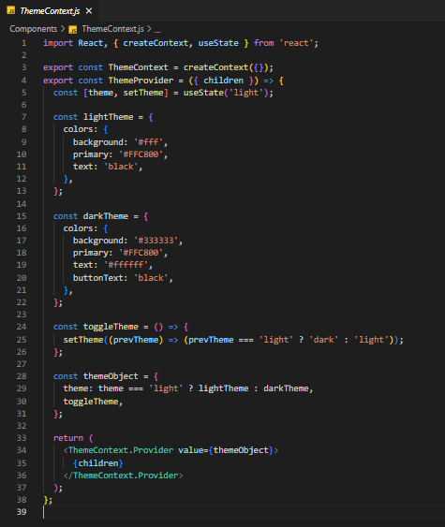

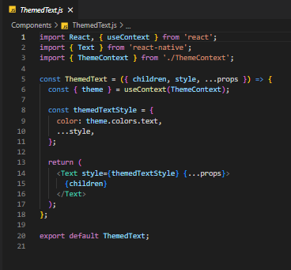

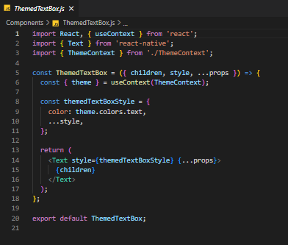

Mobile App theme content layout.

* Display data using components:

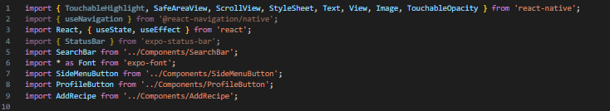

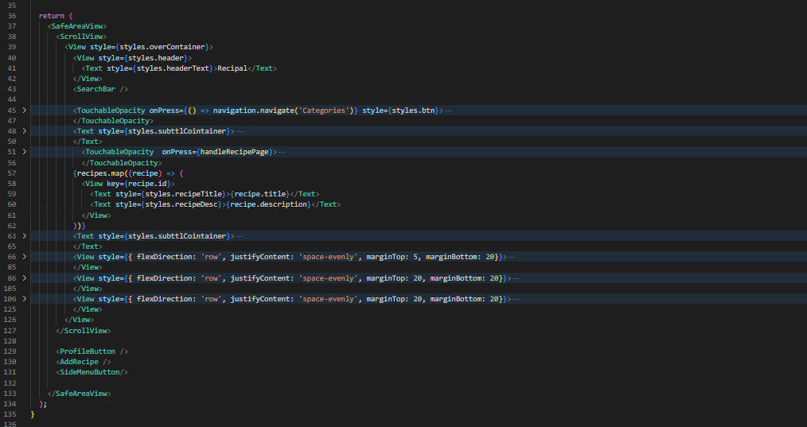

* Secure code practices:

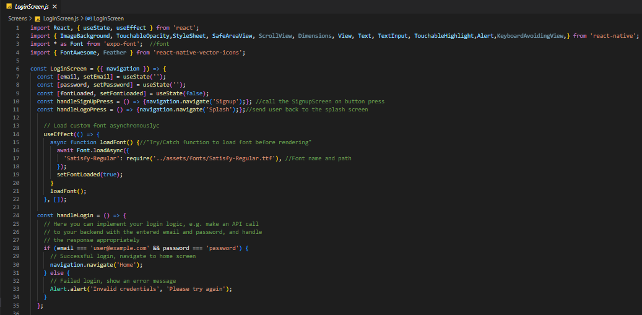

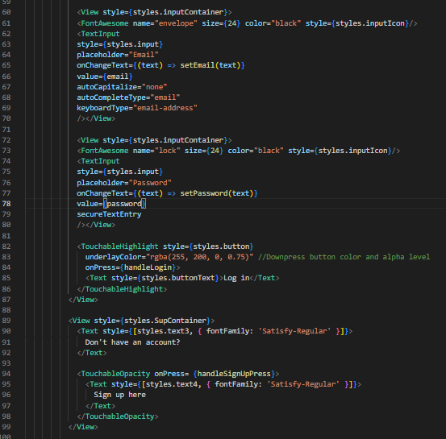

Log In Screen

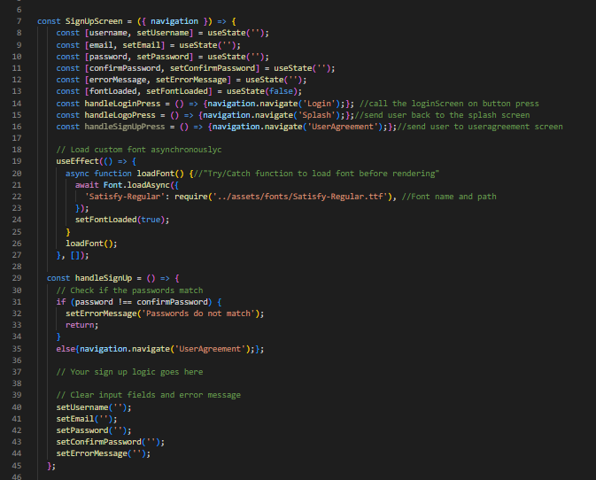

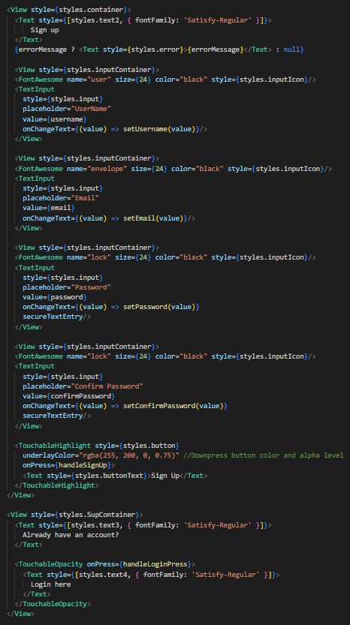

Sign Up Screen

## Task 2: RESTful Web Service

First, RESTful web services are available and hosted via Oracle cloud VPS with Django REST framework as backend. This can be accessible via <http://192.9.174.169/api/>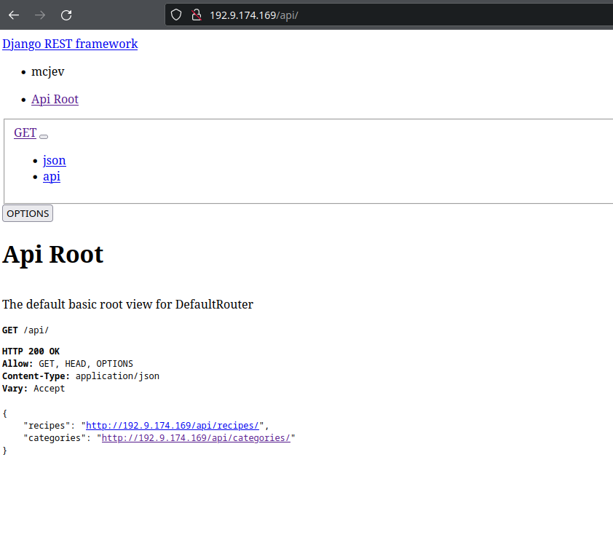

• Call a REST service using HTTP.



• Retrieve data from the web service.



• Parse the response and extract the relevant information.

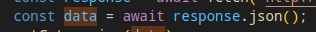

This line is using the json() method of the Response object returned by the fetch() function to extract the response body as a JSON object. The JSON object contains an array of category objects, each with an id, title, and image property. The setCategories(data) function then updates the categories state with this extracted data.

• Displays the information in a user-friendly way, with appropriate use of UI components and design.

Below are the data from RESTapi backend that has been parsed on the front end and displayed on screen.

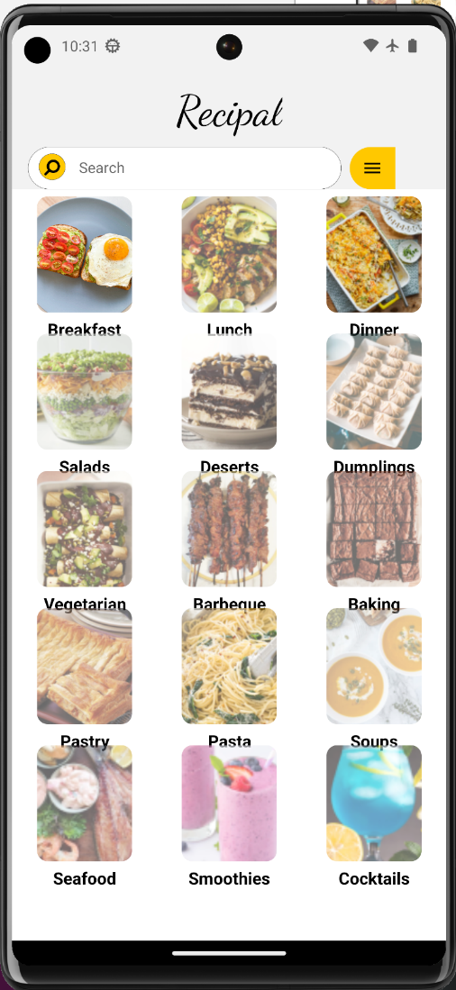

Full code for Restfull API service backend below.

Serializer.py

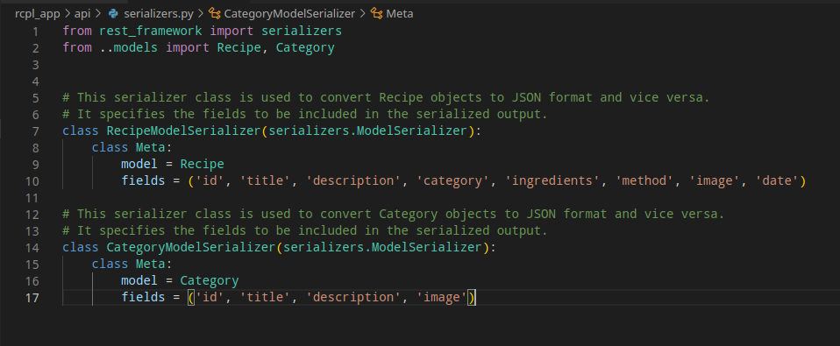

Urls.py

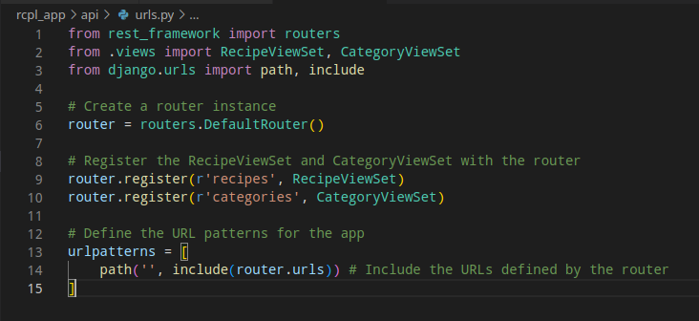

Views.py

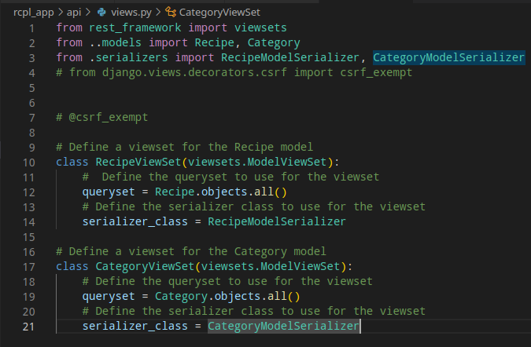

Code for Restful API on frontend below.

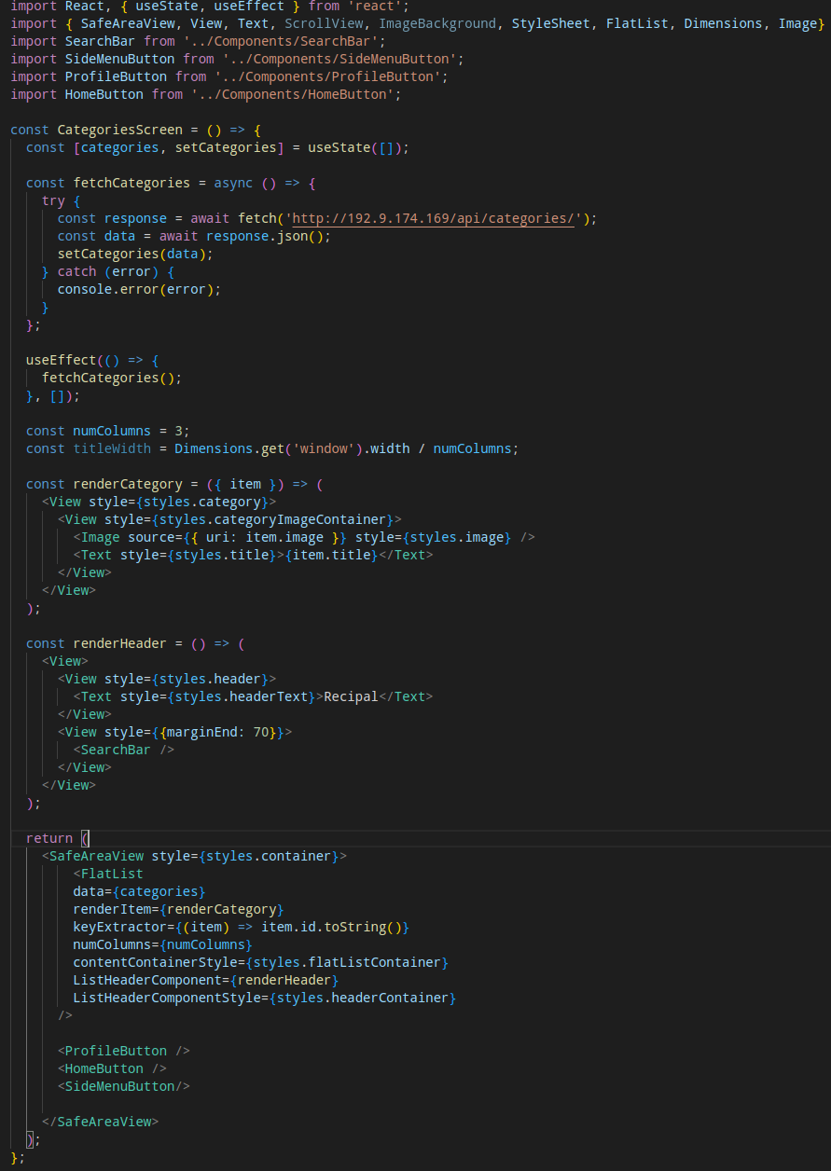

# Part B – Database Integration

## Task 1:

Online Data Integration Storage

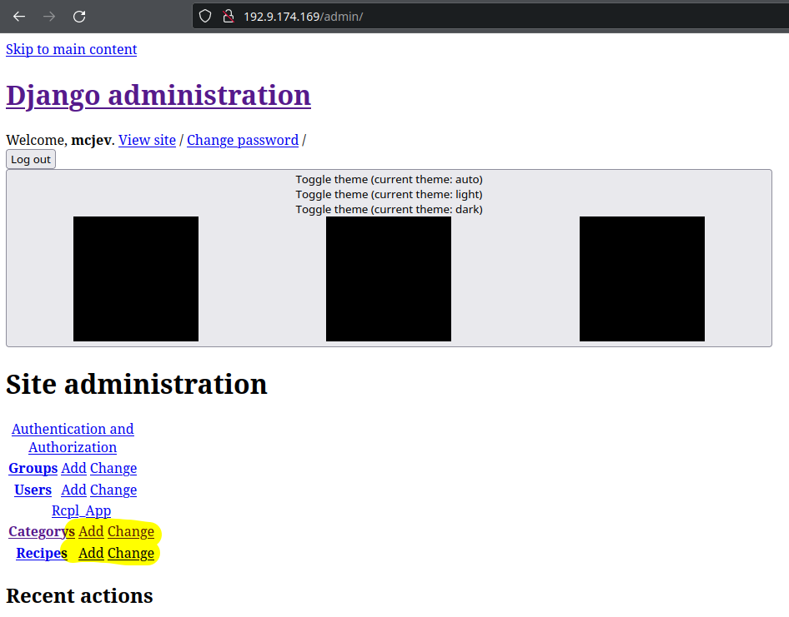

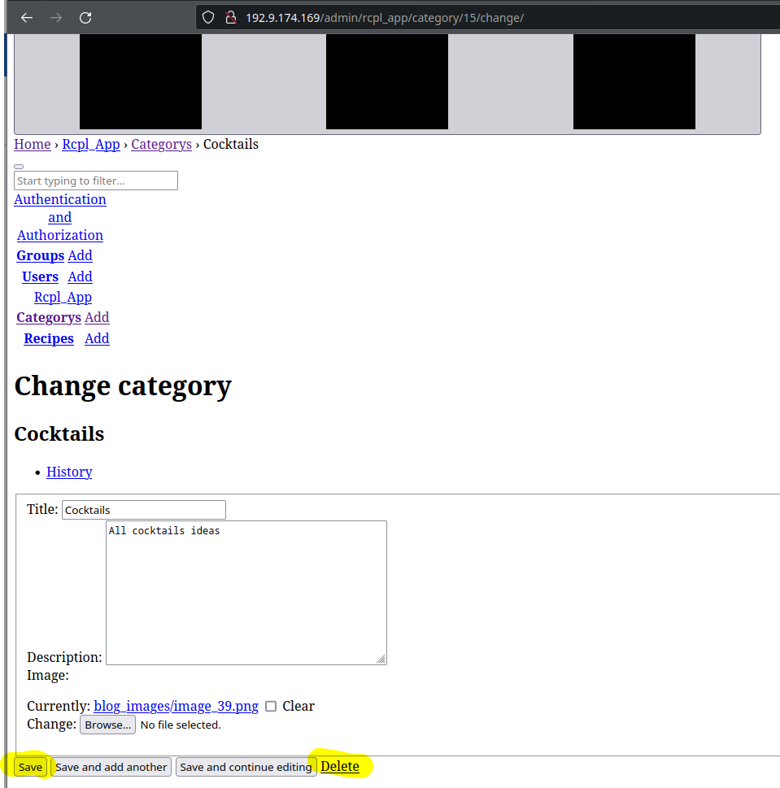

Offline data Integration storage

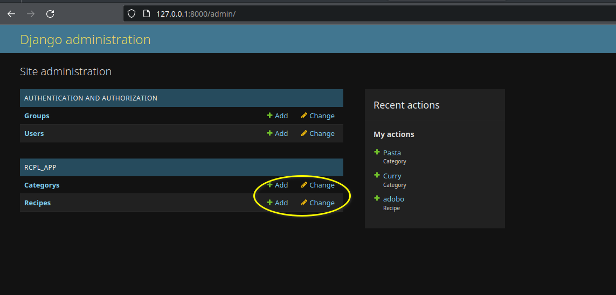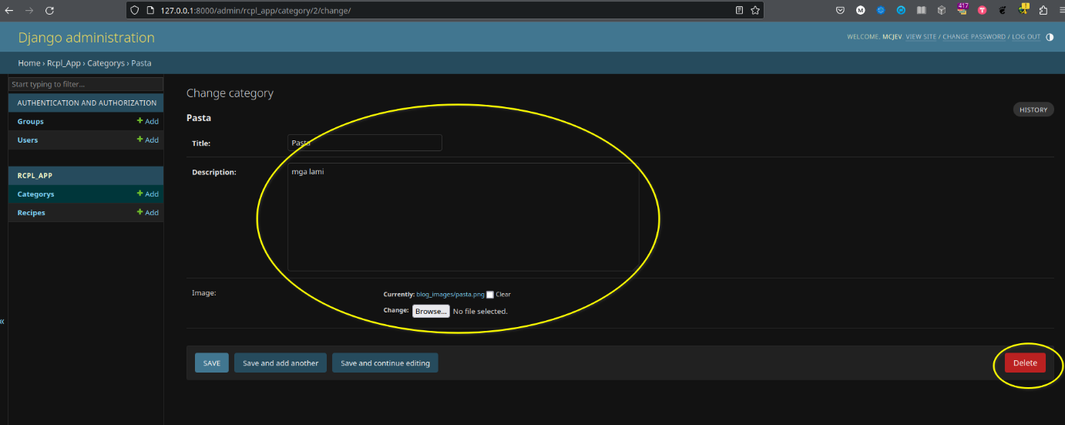

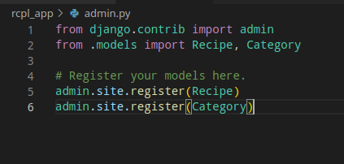

The functions add, delete, update and read is a built-in framework used in Django at the backend.

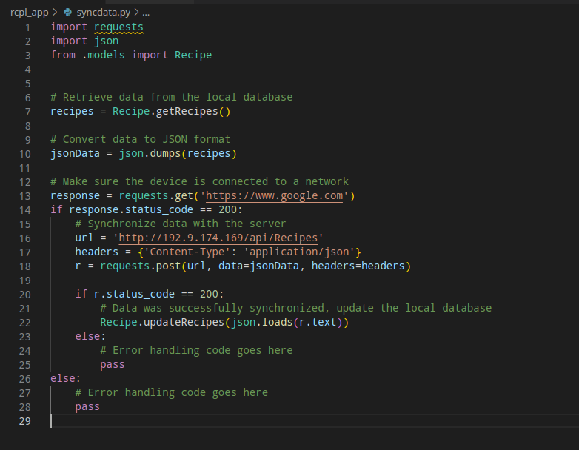

Screenshot above is the code where it initially checks if the app can reach <https://www.google.com>. When it can reach google.com then initiates synchronisation process.

# Part C – Test and Debug

## Task 1: Testing

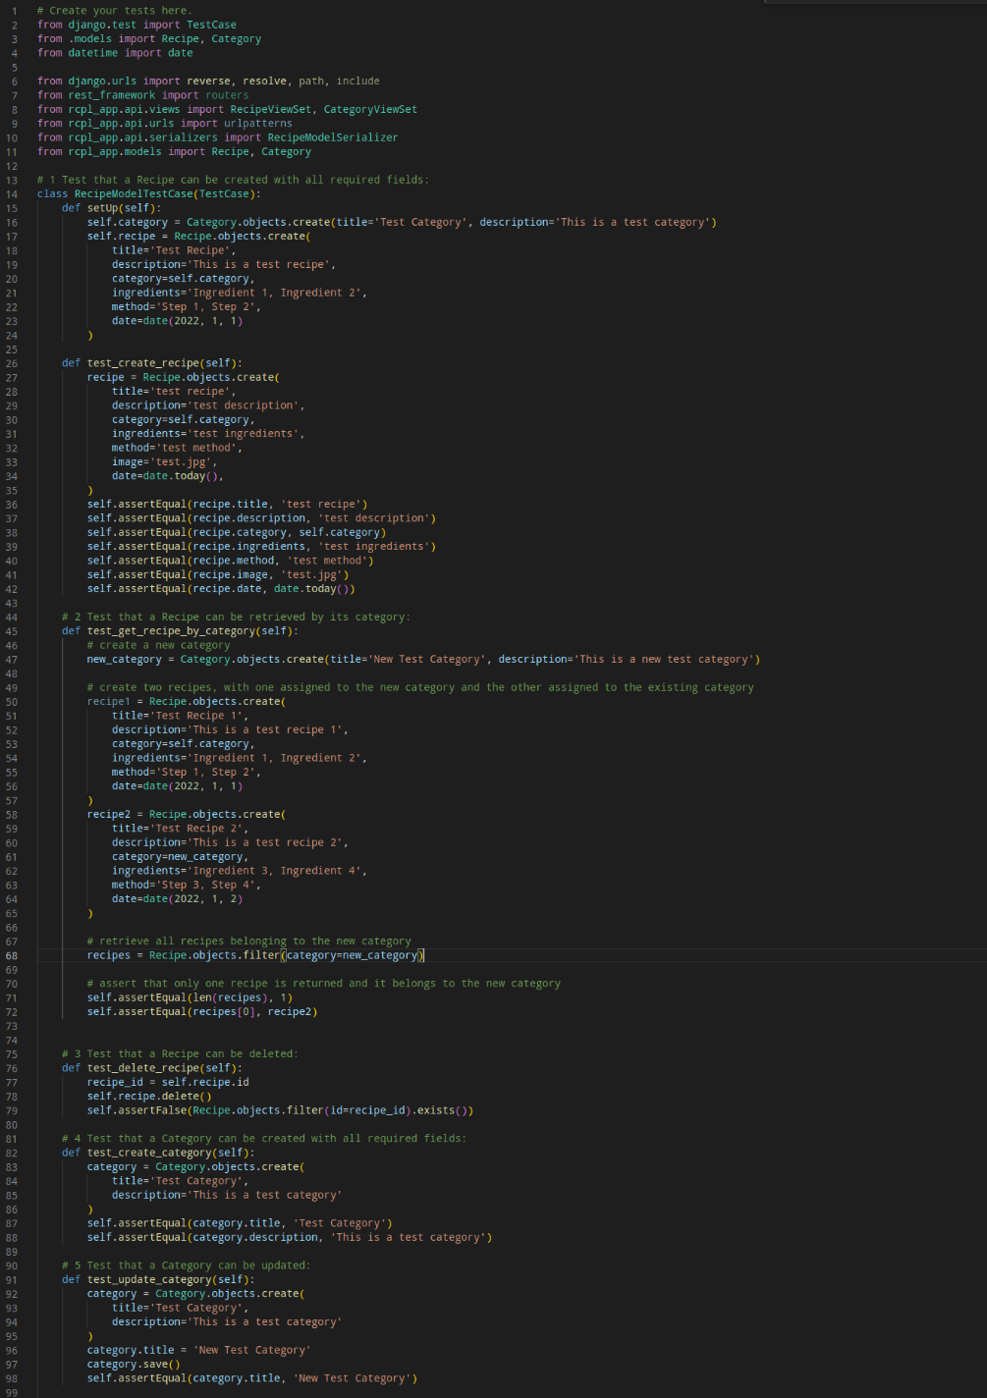

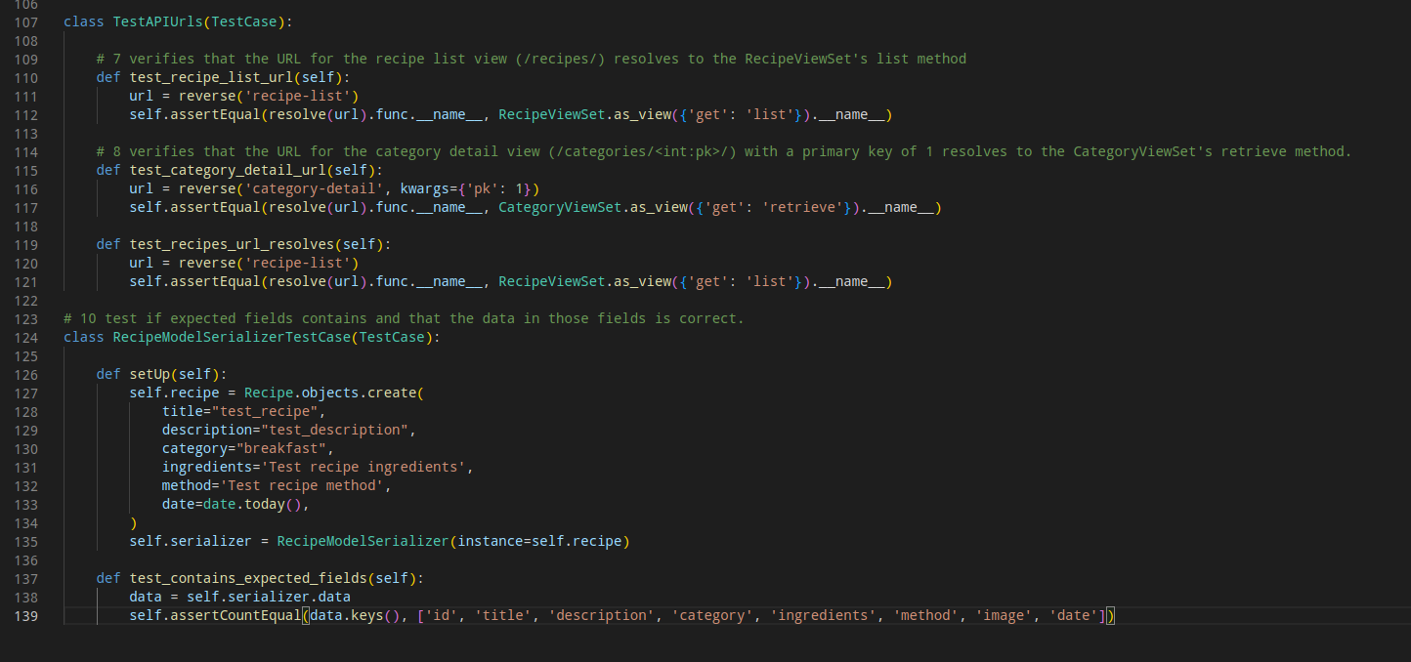

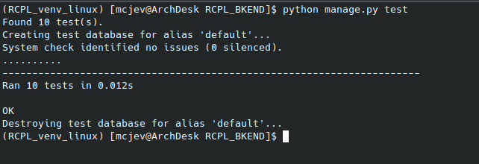

# Part D – Reflection

## Task 1: Self-Reflection

**Marvin Coronel**

* Your role in the project portfolio.

As a backend developer with a focus on API development, cloud integration, and automated testing, I have had the opportunity to work on some exciting and challenging projects. I have learned a lot about designing and building scalable and reliable APIs, integrating with cloud services Oracle cloud structure cloud services, and ensuring the quality and reliability of the code through automated testing.

* Difficulties you faced and lessons learned during the project portfolio.

As a developer, I have faced some significant challenges in my work, particularly when it comes to integrating different technologies and platforms. One of the biggest difficulties I have encountered is learning React Native, a powerful and versatile framework for building mobile apps. Although I have experience with web development and other front-end technologies, React Native presented a new set of challenges, particularly when it came to dealing with the native components and APIs of different mobile platforms.

Another challenge I faced was integrating a RESTful API framework with a frontend in React Native. Integrating this with a frontend in React Native required a different set of skills and knowledge. I had to learn how to handle asynchronous requests, manage state and data flow, and handle errors and exceptions in a mobile context.

Another difficulty was making the API accessible via NGINX, Unicorn/WSGI, and Django. This required a deep understanding of the underlying architecture of these technologies, as well as an ability to troubleshoot issues and optimize performance. I had to learn how to configure NGINX to serve static files and proxy requests to the backend, how to use Unicorn/WSGI to manage the application server, and how to optimize the performance of Django by tweaking various settings and configurations.

Finally, I faced challenges in deploying a Django backend on Oracle Cloud. Although I had experience with deploying Django on Oracle Cloud, it presented a new set of challenges. I had to learn how to set up the infrastructure, configure the servers and databases, and manage security and access control.

Despite these challenges, I am proud of the work I have done in overcoming them. By learning new skills and technologies, and by persevering through difficult problems, I have become a better developer and a more valuable member of my team. I look forward to continuing to learn and grow in my work, and to tackling new challenges and opportunities as they arise.

* What worked best during the project portfolio.
* Team is open to learn new things. Openminded.
* Team listens to innovative ideas and are not afraid to try it out.
* GitHub collaboration
* Trello works well. The user stories and dividing it to sub-user stories and dividing again to micro-tasks.
* Team initiative. The team picks user-stories that they are confident to work and finish.
* Stand-up meetings work well as we all discuss all the updates, what we are working on, what we plan to work on and which part we are stuck on.
* The team has can-do attitude.
* Team helps each other.
* Team teaches other team members.
* Team do not take it seriously. We do have some casual laughs to lighten up.
* What would you do differently if you had a chance to redo the project portfolio with the same team?
* Start to learn early on programming language, tools, and frameworks.
* Perform a team code review to ensure only working code is pushed to GitHub remote repository.
* Improve on communication and clarity on those goals of the tasks.
* Shorten stand-up meetings and only focus on the agenda.
* Include coding standards.

## Task 1: Self-Reflection

**Rocelle Valdez**

* Your role in the project portfolio.

As the front-end developer, my role in the project designing and developing the application's user interface and user experience oversaw ensuring that the application's front-end is visually appealing, easy to use, and offers users a consistent experience.

* Difficulties you faced and lessons learned during the project portfolio.

Having a responsive design since mobile devices have different screen sizes, resolutions, and orientations, designing for mobile is difficult. It is critical to create a design that is responsive that adjusts to different screen sizes and orientations to ensure a consistent user experience across different devices.

* What worked best during the project portfolio.
* GitHub collaboration
* Trello was properly used to match the development of the mobile application.
* Team members are taking responsibility for every task they assigned their selves to do.
* The team has can-do attitude.
* Team helps each other.
* Team member takes suggestions well and incorporate it to the project.
* What would you do differently if you had a chance to redo the project portfolio with the same team?
* Start early and make sure that the basic components are working in the early stages of the project.
* Improve on communication and clarity on those goals of the tasks.
* Have a short and precise meeting that tackles only the important topics that needs to be discussed.

## Task 1: Self-Reflection

**Darren Burton**

* Your role in the project portfolio.

Working on the physical development of the Recipal project in React Native has been an exciting and challenging experience. As the front-end developer on the project, I was responsible for implementing the wireframes and UI mock-ups created by the team, as well as integrating various components and functionalities into the application.

* Difficulties you faced and lessons learned during the project portfolio.

One of the challenges I faced was installing and configuring the necessary packages and dependencies to get the project up and running. This required extensive troubleshooting and research, but with the help of my team members and online resources, I was able to overcome these obstacles.

* What worked best during the project portfolio.

Designing the user interface in React Native was particularly enjoyable for me. It allowed me to use my creativity and problem-solving skills to design a visually appealing and user-friendly interface for the application. This involved working closely with the team to ensure that the UI met the user requirements and preferences, as well as implementing various design elements and animations to enhance the user experience.

Implementing various components and functionalities into the application was also a rewarding experience. This involved working with various third-party libraries and APIs, such as the star rating component and the recipe search API, to add new features and improve the overall functionality of the application. It required attention to detail and strong programming skills, but I was able to successfully integrate these components into the application.

* What would you do differently if you had a chance to redo the project portfolio with the same team?

If I had the chance to work on the project again, there are a few things I would do differently:

Allow more time for testing and debugging.

Establish a more streamlined workflow for version control and collaboration.

Prioritize accessibility and usability in the design and development process.

Overall, I am proud of the work I have accomplished on the project. It allowed me to develop my skills in front-end development, troubleshooting, and collaboration, and provided me with valuable insight into the software development process. I believe that our project has the potential to make a positive impact on the cooking and baking community, and I am excited to see how it will evolve in the future.